

National University of Sciences &

Technology Islamabad

School of Mechanical and Manufacturing

Engineering (SMME)

**Computer Systems & Programming Lab**

Mechanical Engineering -15 Section B

**Home Task:**

**Submitted by:**

Muhammad Shahzeb Khan

**Registration #:**

479677

**Submitted to:**

Lab Instructor Sir Muhammad Affan

**Question 1 Write code to calculate factorial of 6.**

#include<iostream>

using namespace std;

int main()

{

int num1=6;

int num2;

cout << “num1” << endl;//factorial of 6 Is to be calculated

num2=num1*(num1-1)*(num1-2)*(num1-3)*(num1-4)*(num1-5);//formula for calculating factorial

cout << “num2 is” <<num2<< endl;//answer of factorial of 6

return 0;

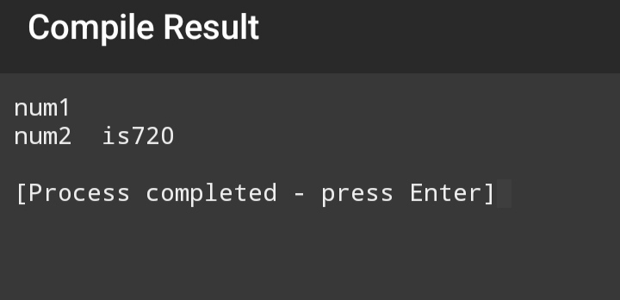}

**Question 2 Write code to find distance between two points.**

#include<cmath>

#include<iostream>

using namespace std;

int main()

{ float x1,x2,y1,y2,d;

cout<<”enter x1”<<endl;//enter coordinate x1

cin>>x1;

cout<<”enter x2”<<endl;//enter coordinate x2

cin>>x2;

cout<<”enter y1”<<endl;//enter coordinate y1

cin>>y1;

cout<<”enter y2”<<endl;//enter coordinate y2

cin>>y2;

d=sqrt((pow(x2-x1,2))+(pow(y2-y1,2)));// using distance formula

cout<<”distance d between two points is”<<d<<endl;// taking output distance

return 0;

}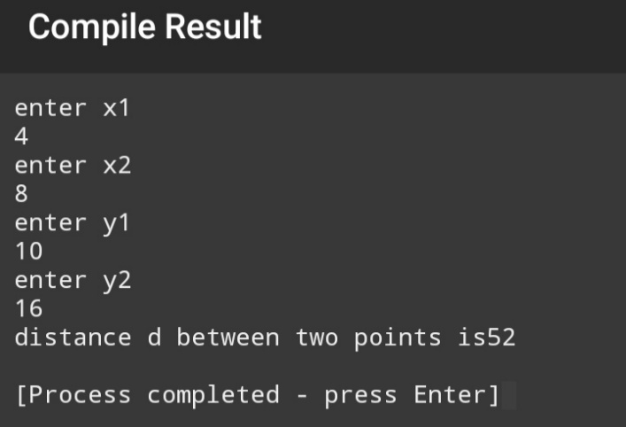

**Question 3 Write code to convert given length in centimetres into**

**meters and kilometres.**

#include<iostream>

using namespace std;

int main()

{ float num1,num2,num3;

cout<<”enter num1 in centimetres “<<endl;//put length in centimetres

cin>>num1;

num2=num1/100;// conversion formula into meters from centimeters

cout<<”num2 in meters is “<<num2<<endl;

num3=num1/100000;// conversion formula from centimeters to kilometres

cout<<”num3 in kilometres is”<<num3<<endl;

return 0;

}

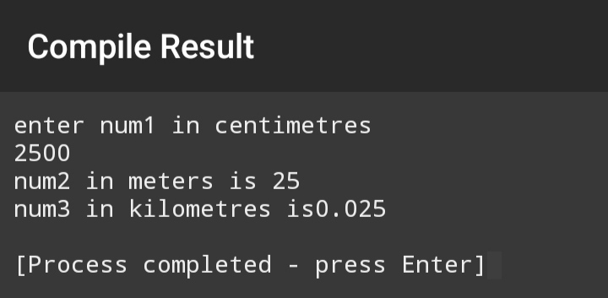

**Question 4 Write code to represent the given value of a & b in a2+2ab+b2.**

#include<cmath>

#include<iostream>

using namespace std;

int main()

{ float a,b,c;

cout<<”enter a”<<endl;// entering first number a

cin>>a;

cout<<”enter b”<<endl;//entering second number b

cin>>b;

c= (pow (a,2))+(pow (b,2))+2*a*b;// formula of required calculation

cout<<”c is “<<c<<endl;

return 0;

}

